Add audio and video

Add, format, and record video
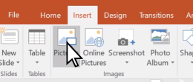
In PowerPoint, you can add animated GIFs, videos from your computer or online videos, recordings, export your presentation as a video, and even add captions to videos.
Add an animated GIF
- Select Insert > Pictures.
- Select the animated GIF you want to add.
- Select Slide Show to see the animated GIF play.

Add a video
Select Insert > Video and then choose:
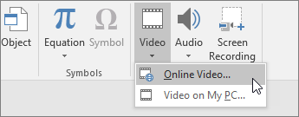
- Online Video: Add a video from YouTube or paste in an embed code.
- Video on my PC: Add a video that's stored on your computer.

Screen recording
- Select Insert > Screen Recording.
- Select the area you want to record.
- Select Record.
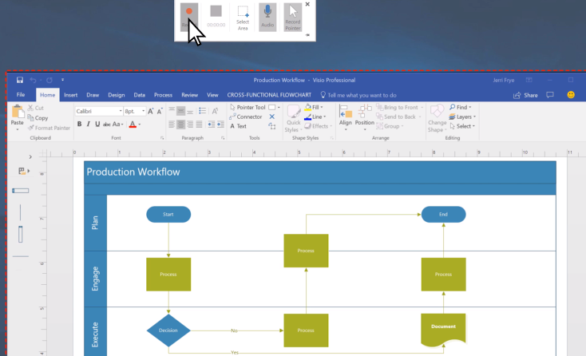
Record your presentation
- Select Slide Show > Record Slide Show.
- Select if you want to:
  - Record from Current Slide
  - Record from Beginning
Add captions to videos
Note: Captions can't be added to online videos. For more information, see Create closed captions for a video.
- Select the video you want to add captions to.
- Select Video Tools > Playback > Insert Captions.
- Select the caption file and select Insert.
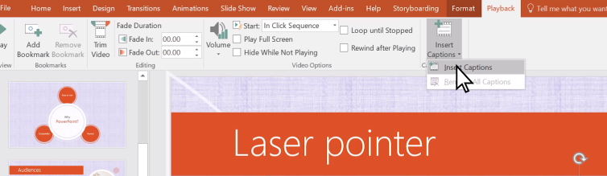
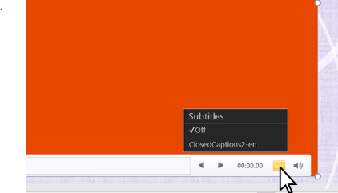
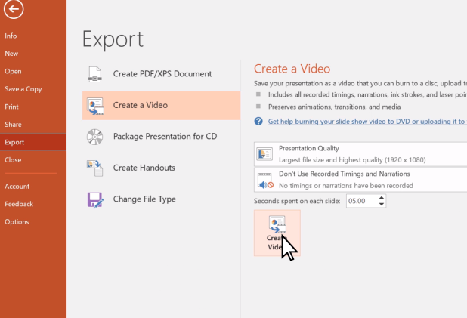
Export your presentation as a video
- Select File > Export.
- Select Create a Video.
- Select your settings.
- Select Create Video.

Format your video
- Select and drag to resize and move your video around.
- Select Format to put frames and effects on your video.
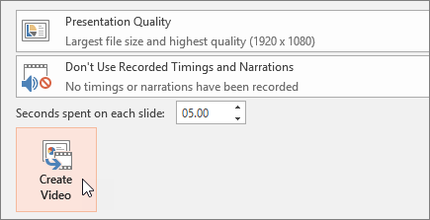
- Select Video Effects, Video Border, or Video Shape to add effects, borders, or crop your video to a shape.
- Select Corrections or Color to adjust the video’s color tone.
- Select Poster Frame to choose the video’s opening frame, and then click and drag with your mouse to select your preferred frame. Select Poster Frame > Current Frame to confirm your choice.

Add and record audio
Add or record audio, such as music, narration, or sound bites, to your PowerPoint presentation.
Add audio
- Select Insert > Audio.
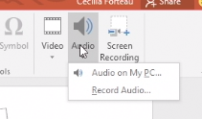
- Select how you’d like to add audio:
  - Audio on My PC – Insert an audio file already on your PC.
  - Record Audio – Record audio from a microphone attached to your computer.

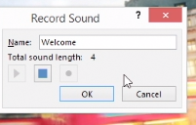
Add recorded audio
- Select Record Audio.
- Type in a name for your audio file, select Record, and then speak.
- To review your recording, select Stop and then select Play.
- Select Record to re-record your clip, or select OK if you’re satisfied.
- To move your clip, select and drag the audio icon to where you want it on the slide.
Note: If you’re using more than one audio file per slide, it’s advisable to put the audio icon in the same spot on a slide to find it easily.
- Select Play.
Adjust recorded audio
- Select the Audio Tools Playback tab, and then select which options you'd like to use:
  - To trim the audio, select Trim and then use the red and green sliders to trim the audio file accordingly.
  - To fade in or fade out audio, change the number in the Fade Duration boxes.
  - To adjust volume, select Volume and select the setting you prefer.
  - To choose how the audio file starts, select the dropdown arrow and select an option:
    - On Click – Plays the audio file automatically with a click.
    - Automatically – Plays automatically once you advance to the slide that the audio file is on.
  - To choose how the audio plays in your presentation, select an option:
    - Play Across Slides – Plays one audio file across all slides.
    - Loop until Stopped – Plays an audio file on loop until it’s stopped manually by clicking the Play/Pause button.
  - To have the audio play continuously across all slides in the background, select Play in Background.
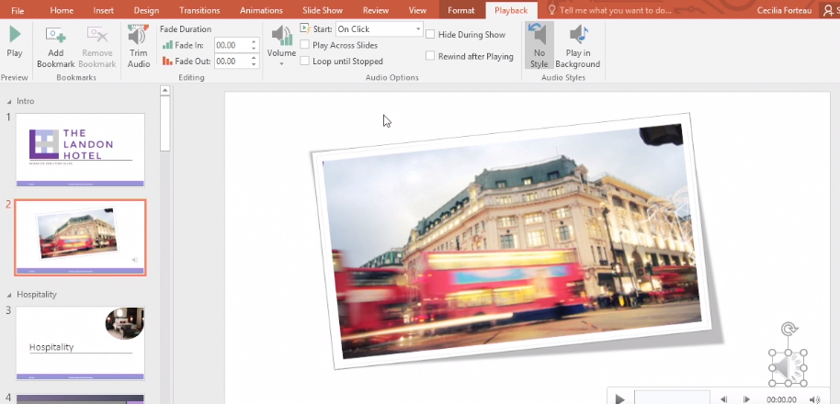
Delete audio
- To delete audio, select the audio icon on the slide and press Delete.

